*Traffic sign detection based on image processing*

Ayşegül TERZİ 1, Oktay KAYA 1

1 Dept. of Computer Engineering, Eskisehir Technical University, Eskisehir, Turkiye

aysegulterzi@eskisehir.edu.tr, oktaykaya@eskisehir.edu.tr

**Abstract**

This paper describes a software application for traffic sign recognition. Traffic sign detection with image processing has become one of the most popular image processing topics in recent times. This paper proposes a system that will detect and classify different types of traffic signs from images. Two methods have been used for detection and recognition purposes; one classifies the color and other the contour. The application works in four stages. After the image is taken, two masks, red and blue, are applied to the image with special boundaries and we apply morphological transformation. Then, the contours in the image are detected and the two results are combined. The results obtained show a good performance of the developed application, taking into account acceptable conditions of size and contrast of the input image.

***Keywords: Traffic sign detection, image processing, image, sign recognition.***

# Introduction

A.History

In recent years, with the outbreak of Artificial Intelligence (AI), In particular, car companies have renewed their driving modes. Over time, vehicles have become able to warn drivers and protect them from accidents. These features make vehicles more interesting, popular and therefore more expensive lately. so the sales market of vehicles has increased.

In addition to the auxiliary driving systems, development of autonomous vehicles also requires rapid and accurate detection of traffic signs from digital images.

B.Feature

Traffic Sign Recognition is to detect the location of traffic signs from digital images, given a specific classification The Traffic Sign Recognition methods basically make use of visual information such as shape and color of traffic signs.

C.Result

The research outcomes in Traffic Sign Recognition not only avoid traffic accidents and protect drivers, but also help inspect traffic signs on roads efficiently and accurately, which reduces unnecessary manpower and resources. It also provides benefits for both the individual and the country in terms of economy.

# Proposed Method

We propose a program with color and contour detection for recognition of a traffic sign. The proposed method consists of 3 stages. These stages are Image Reading, Traffic sign detection and Output Image. Block diagram of the proposed method is shown Fig. 2. RGB format image that is taken from the camera is primarily given to the traffic sign detection algorithm as an input parameter.

Traffic signs are detected with image processing techniques. Traffic sign recognition algorithm by using color and contour detection both runs faster and gets more correct results thanks to associating positive aspects of algorithms in the literature. Flowchart of the traffic sign detection algorithm of the proposed method is shown in Fig. 2.

In the traffic sign detection stage, RGB format image is firstly converted to HSV format image.Then, some filter techniques are applied to the image. This filter is an opening filter. Finally, labeling of the sign regions is performed. The working logic of this filter is shown in Figure 2.



Figure 1

(In [mathematical morphology](https://en.wikipedia.org/wiki/Mathematical_morphology), opening is the [dilation](https://en.wikipedia.org/wiki/Dilation_(morphology)) of the [erosion](https://en.wikipedia.org/wiki/Erosion_(morphology)) of a [set](https://en.wikipedia.org/wiki/Set_(mathematics)) A by a [structuring element](https://en.wikipedia.org/wiki/Structuring_element) B)

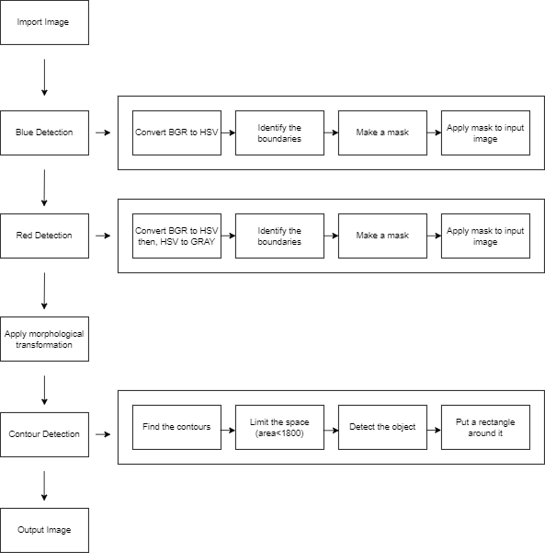

Figure 2

## Experimental Results

We did not have much time and opportunity to try this project. So, we were only able to calculate the f1-score and it is as follows :

precision : 0,91

recall : 0,83

F1-score = 2 x (precision x recall) / (precision + recall)

so, F1-score = 0,87

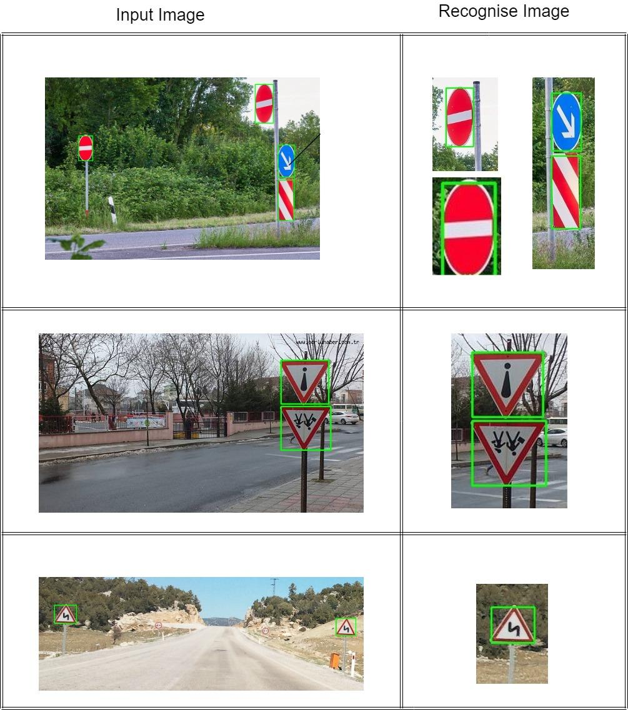

Figure 3

## Conclusions

An algorithm based contactless image processing using color and contour detection was suggested to detect the traffic sign detection. Traffic signs were detected using traffic signs imaged under diverse angle cases. RGB to HSV Color format conversion, Opening filter were applied to input images.

So traffic signs were detected by applying these image processing techniques.The proposed method was run with utilizing traffic sign images in Python. Opencv, Numpy, and Matplotlib libraries have been used.

Our F1-Score is 0,85. A total of 40 traffic signs were detected in 20 images. As further work, a recognition system can be added to the program.

##### V. References

1. Xue Yuan, Xiaoli Hao, Houjin Chen, and Xueye Wei, “Robust Traffic Sign Recognition Based on Color Global and Local Oriented Edge Magnitude Patterns”,IEEE TRANSACTIONS ON INTELLIGENT TRANSPORTATION SYSTEMS, VOL. 15, NO. 4, AUGUST 2014
2. Ayoub lahyani, MohamedElAnsari, IlyasElJaafari, “Traffic sign detection and recognition based on random forests”, LabSIV, Department of Computer Science, Faculty of Science, IbnZohrUniversity, BP 8106, 80000 Agadir, Morocco, Available online 27 February 2016
3. Ayoub lahyani, MohamedElAnsari, IlyasElJaafari, “Traffic sign detection and recognition based on random forests, ”LabSIV, Department of Computer Science, Faculty of Science, IbnZohrUniversity, BP 8106, 80000 Agadir, Morocco, Available online 27 February 2016
4. Ying Sun, Pingshu Geˆ ,Dequan Liu, “Traffic Sign Detection and Recognition Based on Convolutional Neural Network “,College of Mechanical and Electronic Engineering Dalian Minzu University, 22-24 Nov. 2019
5. Kwangyong Lim,Yongwon Hong,Yeongwoo Choi,Hyeran Byun, “Real-time traffic sign recognition based on a general purpose GPU and deep-learning”,March 6, 2017
6. Rubén LagunaRubén BarrientosL. Felipe BlázquezLuis J. Miguel, “Traffic sign recognition application based on image processing techniques”,Department of Electrical and Automatic Control and Systems Engineering, University of León, August 24-29, 2014